Samuel Davies Proof of Ownership.

Contents
Item #1 Nvidia RTX 3060 12gb Graphics Card 2
Item #2 Riser Cable 3
Item #3 EVGA 650w Power Supply 4
Item 4# Pc case, fans, motherboard, Cpu (intel i5 13500), 16gb Ram (Kingston fury 16gb (8x2)) 5
Items Stacked on Shelf of locked Cabinet 6

Item #1 Nvidia RTX 3060 12gb Graphics Card
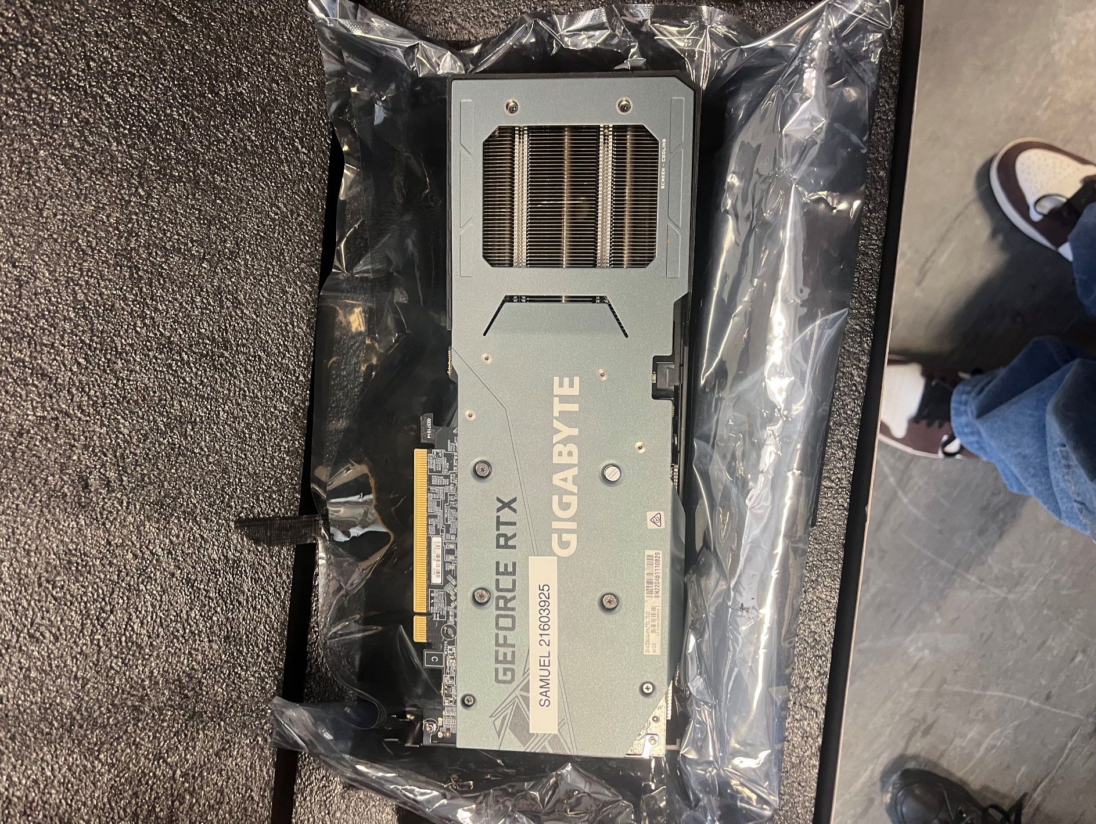
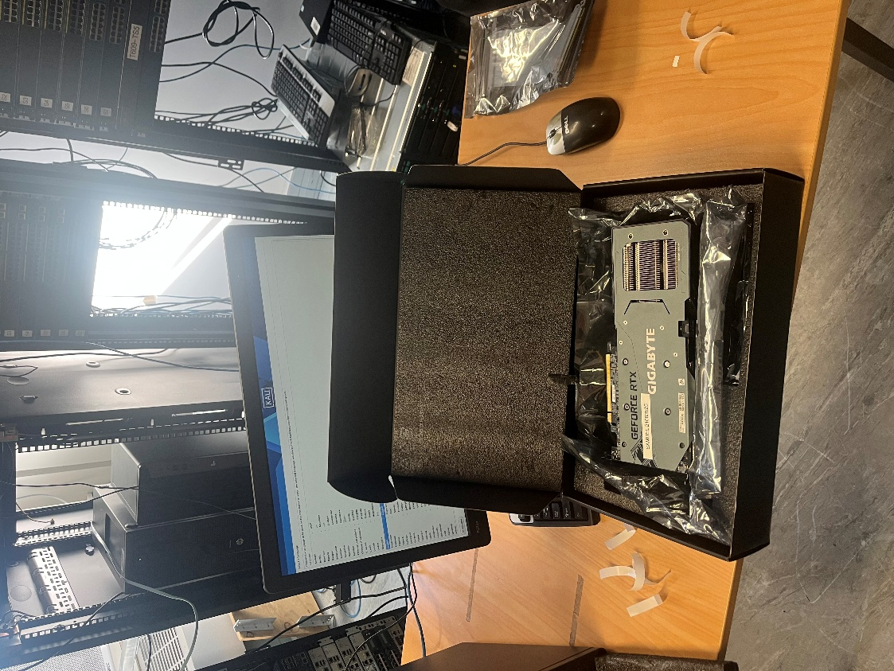

Item #2 Riser Cable
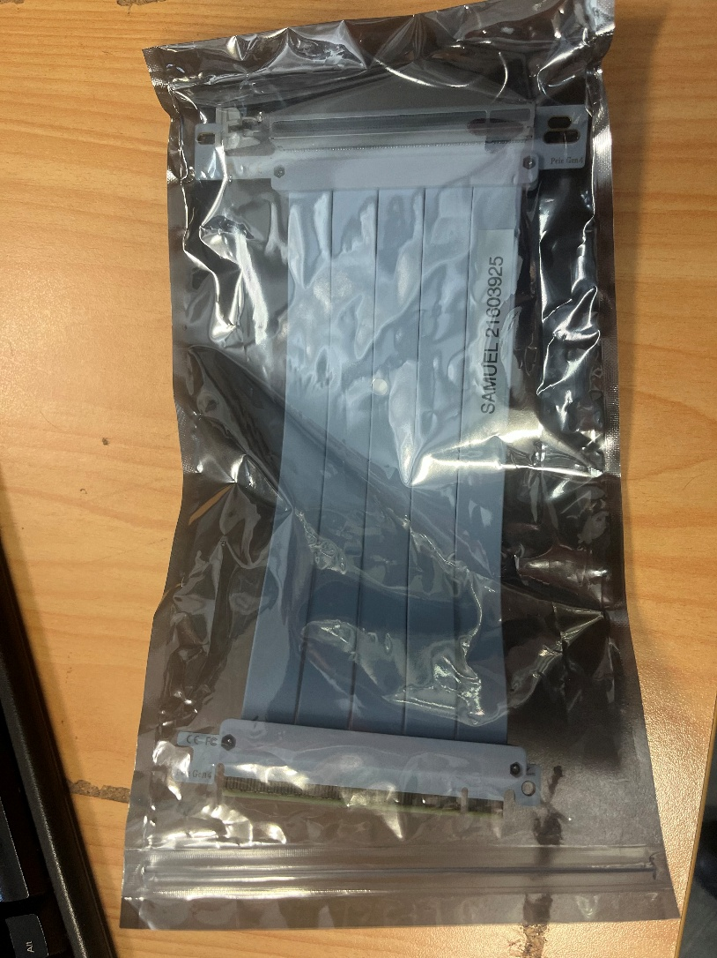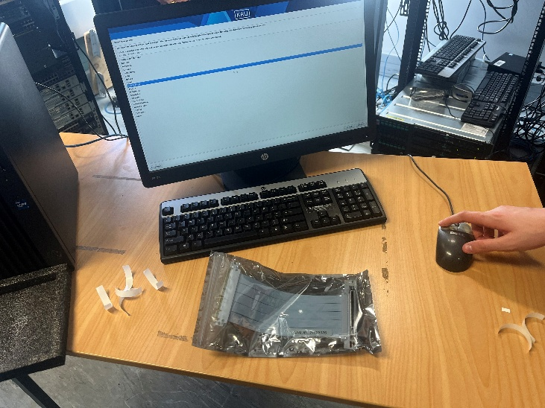

Item #3 EVGA 650w Power Supply
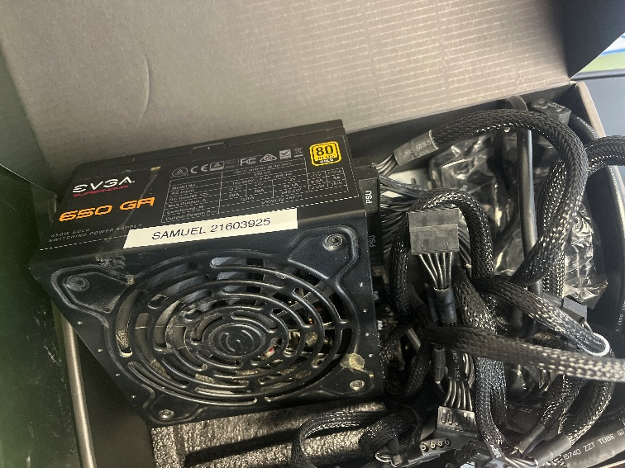
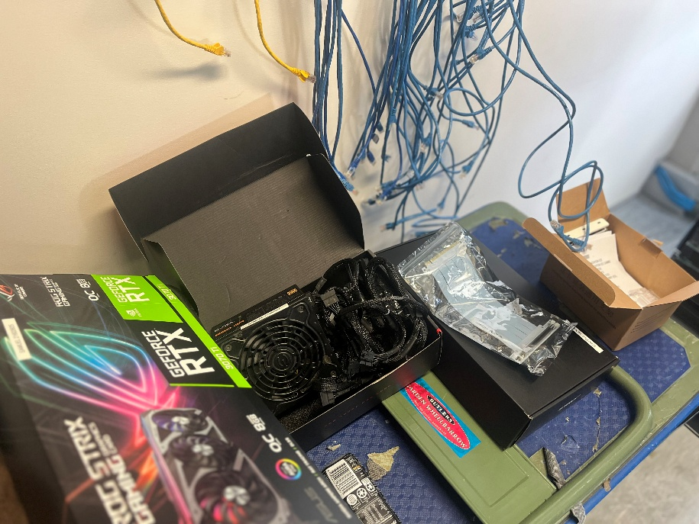

Item 4# Pc case, fans, motherboard, Cpu (intel i5 13500), 16gb Ram (Kingston fury 16gb (8x2))
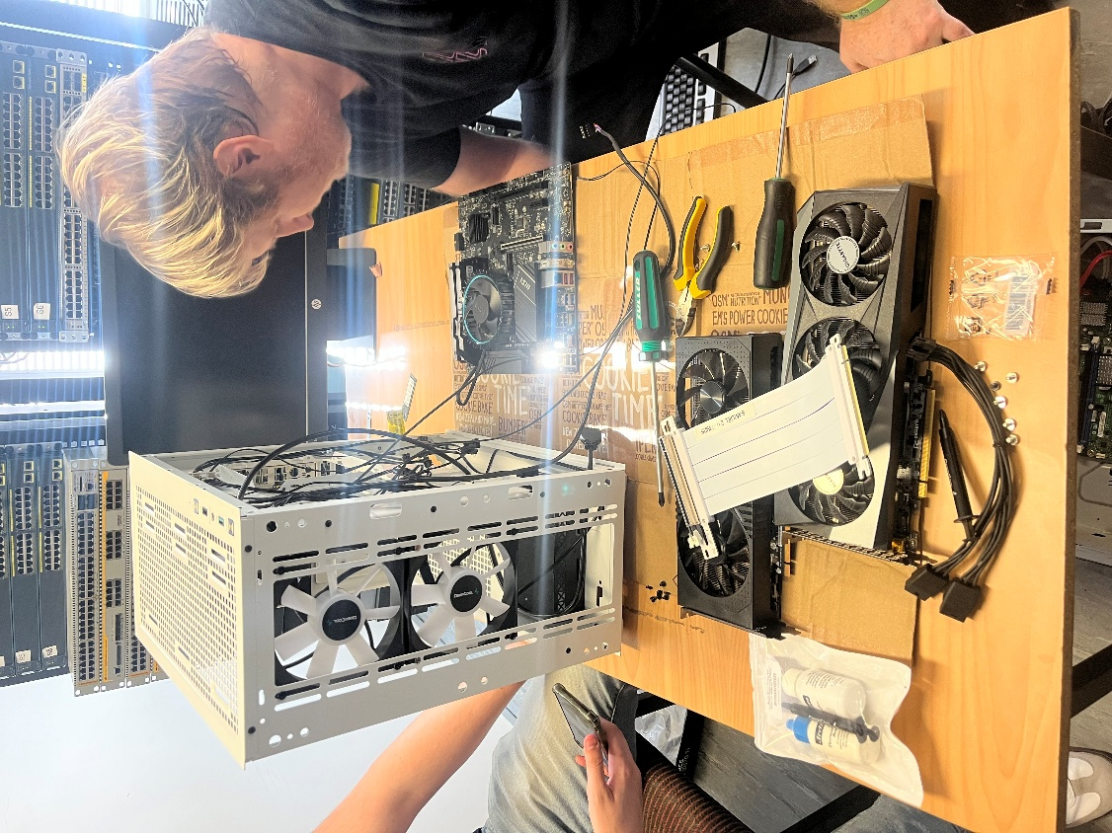

Items Stacked on Shelf of locked Cabinet
